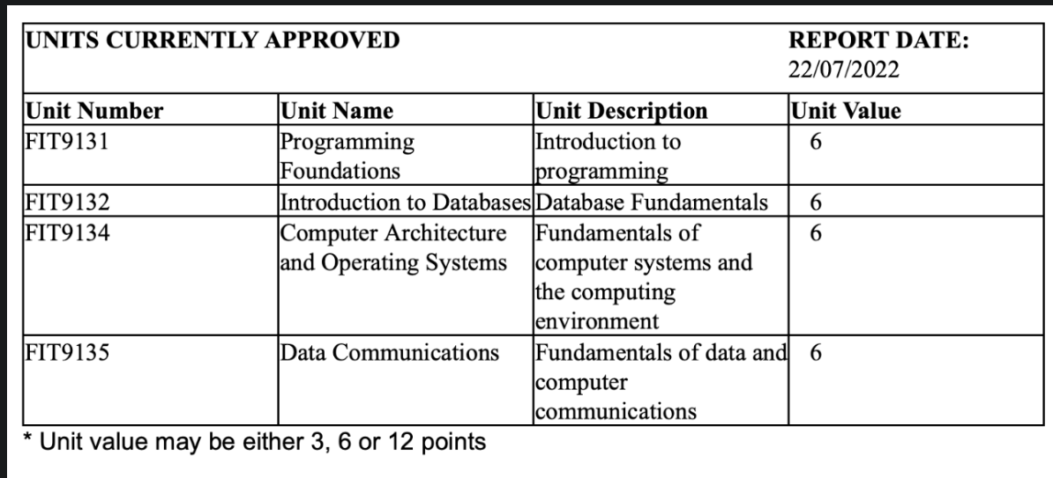  
  
**UNF**UNIT(unit_no, unit_name, unit_desc, unit_value) #report date we do not consider  
  
**1NF**UNIT(unit_no, unit_name, unit_desc, unit_value)   
 **CK**unit_no

**PK**  
unit_no  
  
**Partial dependencies**  
NONE  
  
**2NF**UNIT(unit_no, unit_name, unit_desc, unit_value)   
  
**Transitive Dependencies**None

**3NF** (non-key attribute depending on another non-key attibute)

**Full Dependencies**unit_no -> unit_name, unit_desc, unit_value